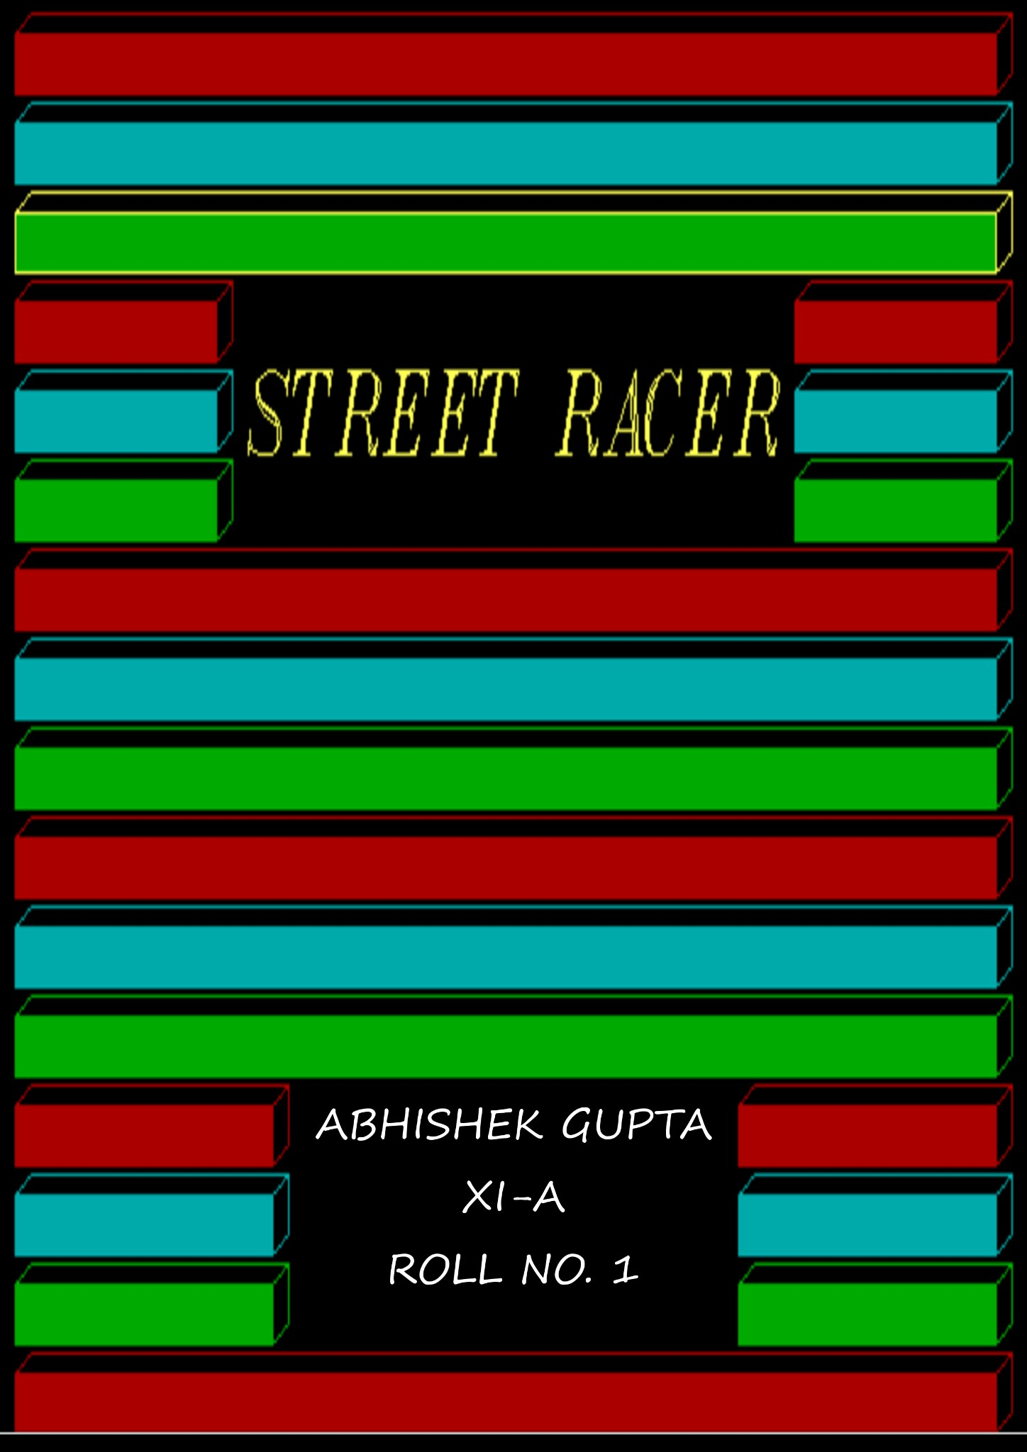INDEX

- CERTIFICATE
- ACKNOWLEDGEMENT
- PREFACE
- HARDWARE AND SOFTWARE REQUIREMENTS
- SNAPSHOTS
- SOURCE CODE
- BIBLIOGRAPHY

CERTIFICATE
This is to certify that ABHISHEK GUPTA of class
XI-A
has prepared his program on
“STREET RACING”
for session 2012-2013 under my supervision.
It is an original piece of work and has not been copied
from any other student or source.

Teacher’s Signature
(MRS. MEETA BHANDULA)

ACKNOWLEDGEMENT

I was able to complete my project well in time by God’s grace.
Firstly, I would like to thank my teacher Mrs.Manpreet Kalra
who had been there every moment to help me in the completion
of my project and improvise my site. They became a guiding
force with the help of whom I have been able to work to the best
of my abilities. I am equally grateful to our computer lab
incharge Mr.Deepak Saini for correcting the technical flaws.
Lastly, I would like to thank my friends Mr.B.Pujari for helping
me out with the colour combinations.

ABHISHEK GUPTA

PREFACE

I feel immense pleasure in presenting the program STREET RACER which is not
a result of impetuous thought but rather it is an outcome of extensive study
from various sources like internet tutorials and C++ programming guides.
The game begins with the idea of user being a street racer breaking the law
and racing to the very end. Hope user doesn’t end up being crashed with the
civilian cars.

HARDWARE AND SOFTWARE REQUIREMENTS

HARDWARE REQUIREMENTS:
Minimum Processor Speed: 1 Ghz
RAM: 512 MB

SOFTWARE REQUIREMENTS:
OS: Windows 98, 2000, XP, Vista, 7, 8.
Software: DOSBox 0.74, Turbo C++ 3.0.

SNAPSHOTS
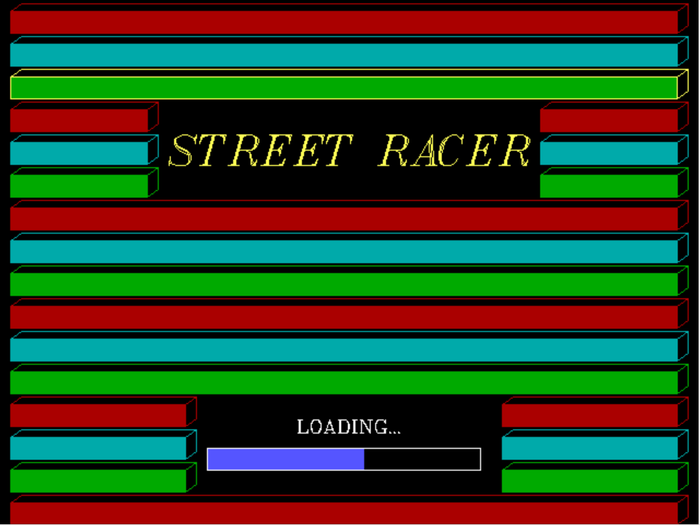
START
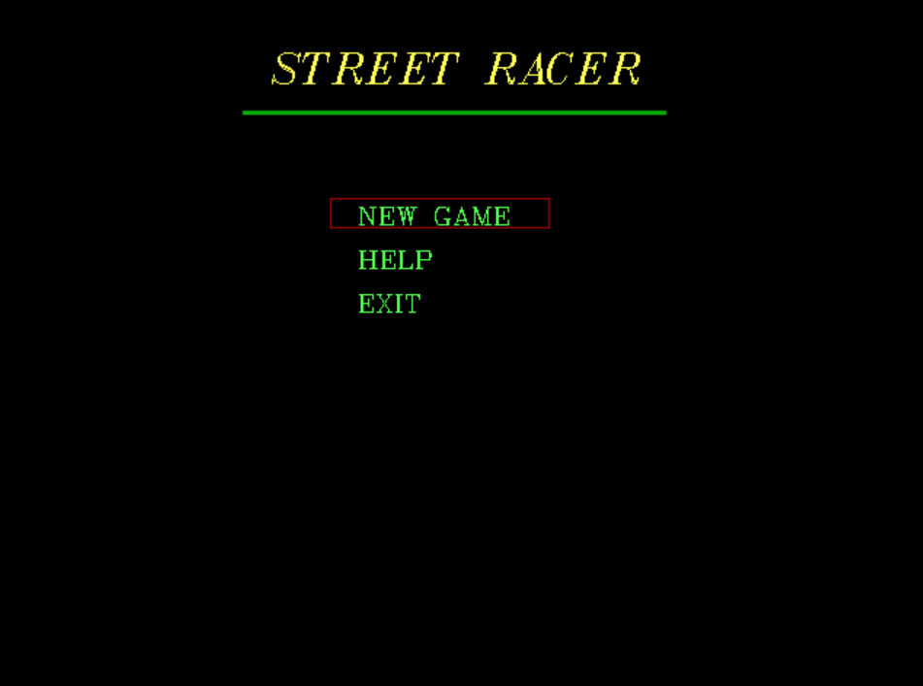
MENU
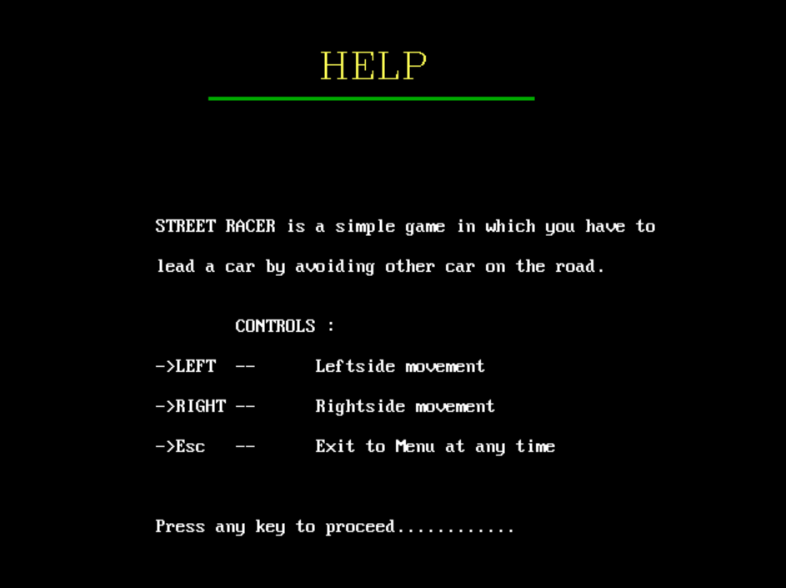
HELP
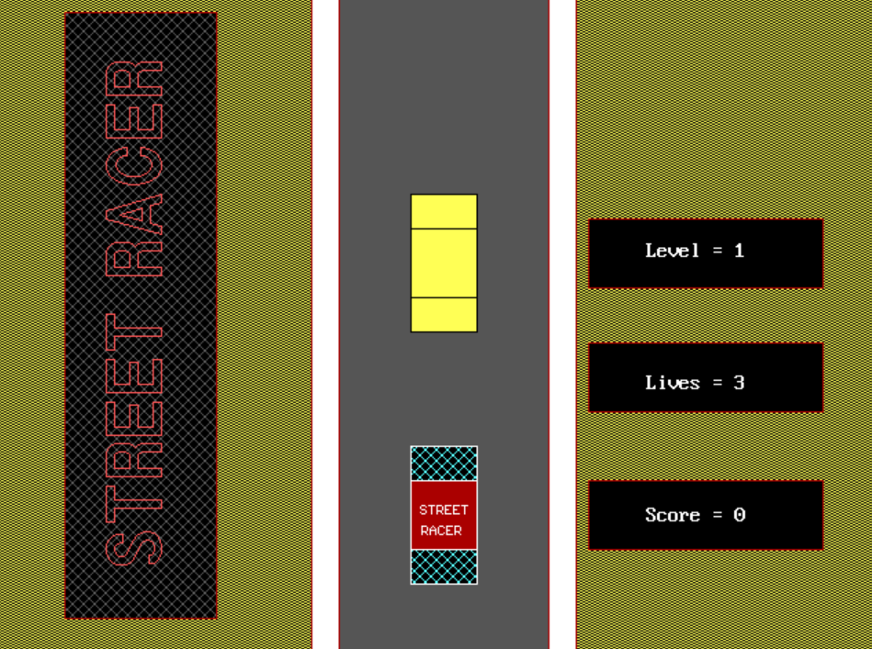
LEVEL 1

NEXT
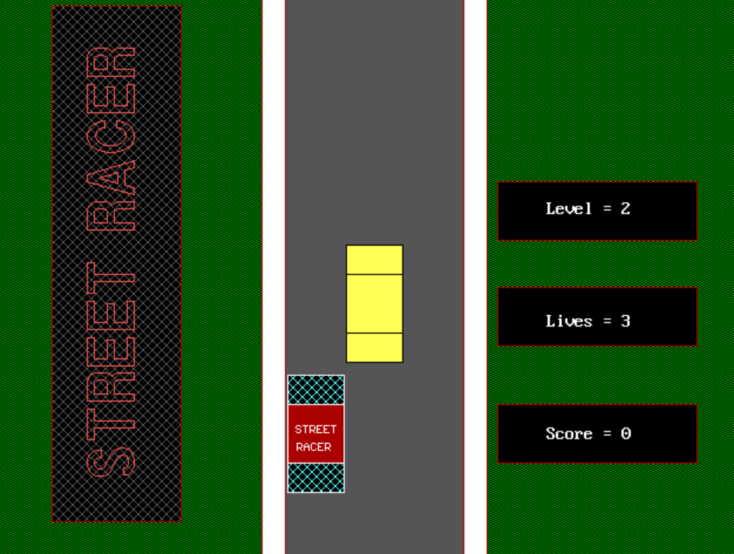
LEVEL 2

CRASH
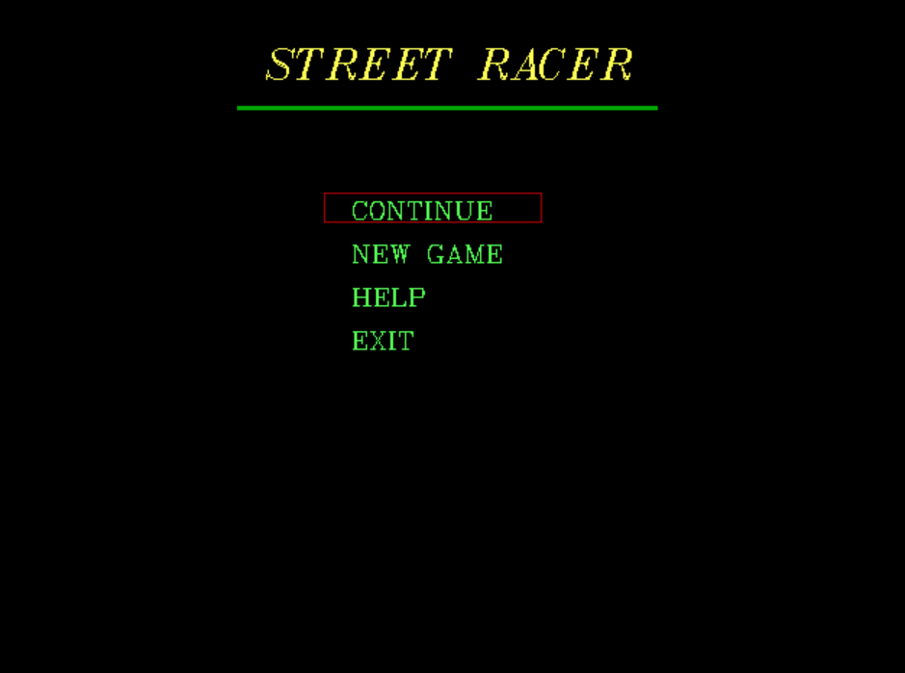
PAUSE
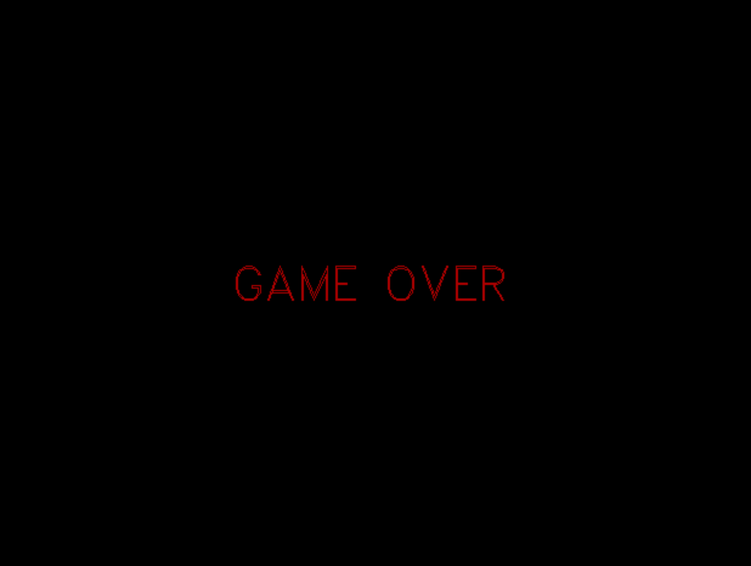
GAME OVER
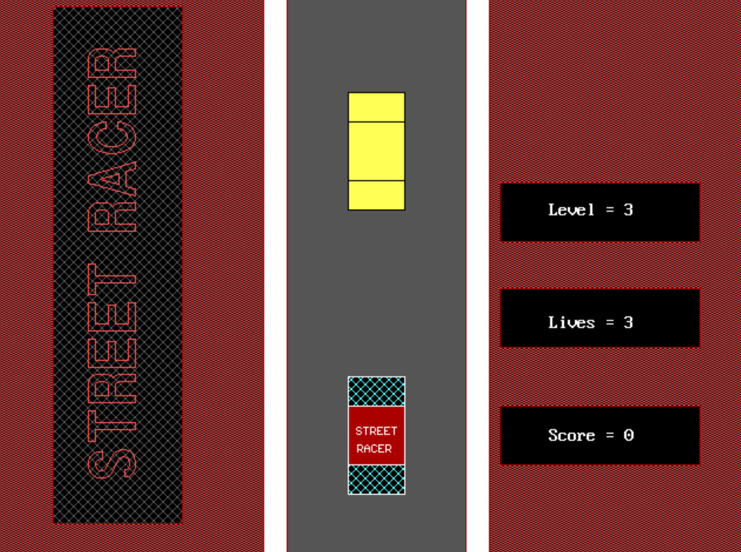
LEVEL 3

WINNER

SOURCE CODE
#include<iostream.h>
#include<conio.h>
#include<graphics.h>
#include<dos.h>
#include<process.h>
#include<stdlib.h>

struct player
{
int level;
int life;
int score;
};

void logo();
void menu();
void new_game();
void race(player any);
void next(player bca);

void mycar(int x7, int y7)
{setcolor(15);
rectangle(x7+1,y7,x7+49,y7+100);
setfillstyle(XHATCH_FILL,11);
floodfill((x7+20),(y7+12),15);
floodfill((x7+20),(y7+87),15);
rectangle(x7+1,y7+25,x7+49,y7+75);
setfillstyle(SOLID_FILL,4);
floodfill((x7+20),(y7+50),15);
setcolor( 15 );
settextstyle( 2, 0 , 4 );
outtextxy((x7+8),(y7+40),"STREET");
outtextxy((x7+9),(y7+55),"RACER");
return ;
}

void civilan(int x8, int y8)
{setcolor(0);
{rectangle(x8+1,y8,x8+49,y8+100);
setfillstyle(SOLID_FILL,14);
floodfill((x8+20),(y8+87),0);}
{rectangle(x8+1,y8+25,x8+49,y8+75);
setfillstyle(SOLID_FILL,14);
floodfill((x8+20),(y8+50),0);}
return ;
}

void clear(int x9,int y9)
{setcolor(8);
rectangle(x9+1,y9,x9+49,y9+100);
setfillstyle(SOLID_FILL,8);
floodfill((x9+25),(y9+50),8);
return ;
}

void logo ()
{
for ( int i = 1;i < 250;i++ )
{
int p;
{ setfillstyle( SOLID_FILL, 4 );
setcolor( 4 );
bar3d( 10, 10, 620, 30, 10, 40 );
setfillstyle( SOLID_FILL, 3 );
setcolor( 3 );
bar3d( 10, 40, 620, 60, 10, 40 );
setfillstyle( SOLID_FILL, 2 );
setcolor( 14 );
bar3d( 10, 70, 620, 90, 10, 40 );
}
{setfillstyle( SOLID_FILL, 4 );
setcolor( 4 );
bar3d( 10, 100, 135, 120, 10, 40 );
setfillstyle( SOLID_FILL, 3 );
setcolor( 3 );
bar3d( 10, 130, 135, 150, 10, 40 );
setfillstyle( SOLID_FILL, 2 );
setcolor( 2 );
bar3d( 10, 160, 135, 180, 10, 40 );}
setcolor( 14 );
settextstyle( 7 , 0 , 5 );
outtextxy( 155, 110, "STREET RACER" );
{ setfillstyle( SOLID_FILL, 4 );
setcolor( 4 );
bar3d( 495, 100, 620, 120, 10, 40 );
setfillstyle( SOLID_FILL, 3 );
setcolor( 3 );
bar3d( 495, 130, 620, 150, 10, 40 );
setfillstyle( SOLID_FILL, 2 );
setcolor( 2 );
bar3d( 495, 160, 620, 180, 10, 40 );
}
{ setfillstyle( SOLID_FILL, 4 );
setcolor( 4 );
bar3d( 10, 190, 620, 210, 10, 40 );
setfillstyle( SOLID_FILL, 3 );
setcolor( 3 );
bar3d( 10, 220, 620, 240, 10, 40 );
setfillstyle( SOLID_FILL, 2 );
setcolor( 2 );
bar3d( 10, 250, 620, 270, 10, 40 );
}
{ setfillstyle( SOLID_FILL, 4 );
setcolor( 4 );
bar3d( 10, 280, 620, 300, 10, 40 );
setfillstyle( SOLID_FILL, 3 );
setcolor( 3 );
bar3d( 10, 310, 620, 330, 10, 40 );
setfillstyle( SOLID_FILL, 2 );
setcolor( 2 );
bar3d( 10, 340, 620, 360, 10, 40 );
}
{setfillstyle( SOLID_FILL, 4 );
setcolor( 4 );
bar3d( 10, 370, 170, 390, 10, 40 );
setfillstyle( SOLID_FILL, 3 );
setcolor( 3 );
bar3d( 10, 400, 170, 420, 10, 40 );
setfillstyle( SOLID_FILL, 2 );
setcolor( 2 );
bar3d( 10, 430, 170, 450, 10, 40 );}
setcolor( 15 );
settextstyle( 8, 0 , 1 );
outtextxy( 273, 375, "LOADING..." );
setfillstyle( SOLID_FILL, 9 );
bar( 190, 410, 190 + i, 430 );
rectangle( 190, 410, 440, 430 );
{ setfillstyle( SOLID_FILL, 4 );
setcolor( 4 );
bar3d( 460, 370, 620, 390, 10, 40 );
setfillstyle( SOLID_FILL, 3 );
setcolor( 3 );
bar3d( 460, 400, 620, 420, 10, 40 );
setfillstyle( SOLID_FILL, 2 );
setcolor( 2 );
bar3d( 460, 430, 620, 450, 10, 40 );
setfillstyle( SOLID_FILL, 4 );
setcolor( 4 );
bar3d( 10, 460, 620, 480, 10, 40 );
}
}
delay( 1000 );
cleardevice();
return ;
}

void won();

void next(player bca)
{
if(bca.level<3)
{ cleardevice();
setcolor( 10 );
settextstyle( 3, 0 , 5 );
outtextxy(200,210, "NEXT LEVEL");
delay(850);
bca.level++;
race(bca);
}
else won();
return ;
}

void over()
{
cleardevice();
setcolor( 4 );
settextstyle( 3, 0 , 5 );
outtextxy(200,210, "GAME OVER");
delay(1200);
getch();
menu();
return ;
}

void won()
{
cleardevice();
setcolor( 4 );
settextstyle( 3, 0 , 5 );
outtextxy(175,210, "YOU HAVE WON");
delay(500);
cleardevice();
setcolor( 14 );
settextstyle( 3, 0 , 5 );
outtextxy(175,210, "YOU HAVE WON");
delay(500);
cleardevice();
setcolor( 10 );
settextstyle( 3, 0 , 5 );
outtextxy(175,210, "YOU HAVE WON");
delay(800);
cleardevice();
menu();
return ;
}

void crash(player abc)
{ abc.life-=1;
if(abc.score>0)
abc.score-=10;
if(abc.life==0)
over();
else
{cleardevice();
setcolor( 4 );
settextstyle( 3, 0 , 5 );
outtextxy(250,210, "CRASH");
delay(400);
race(abc);
}
return ;
}

void help()
{
cleardevice();
settextstyle( 8, 0, 4 );
setcolor( 14 );
outtextxy( 260,30, "HELP" );
setfillstyle( 1, 2 );
bar( 170, 80, 430, 82 );
gotoxy( 3, 6 );
cout << "\n\n\n\n\n\n\t\tSTREET RACER is a simple game in which you have to \n\n\t\tlead a car by avoiding other car on the road.\n\n\n\t\t\tCONTROLS :\n\n\t\t->LEFT\t--\tLeftside movement\n\n\t\t->RIGHT\t--\tRightside movement\n\n\t\t->Esc\t--\tExit to Menu at any time\n\n\n\n\t\tPress any key to proceed............";
getch();
return ;
}

void pause(player cont);

void race(player any)
{
cleardevice();
int x=300,y=325,ch,bk;
setcolor( 4 );
rectangle(50,10,160,450);
setfillstyle(XHATCH_FILL,8);
floodfill(55,20, 4 );
setcolor( 12 );
settextstyle( 10 , 1 , 4 );
outtextxy( 60, 40, "STREET RACER" );
setcolor( 4 );
{rectangle(229,0,249,getmaxy());
setfillstyle(SOLID_FILL,15);
floodfill(239,getmaxy()/2, 4 );}
{rectangle(249,0,401,getmaxy());
setfillstyle(SOLID_FILL,8);
floodfill(325,getmaxy()/2, 4 );} //road
{rectangle(401,0,421,getmaxy());
setfillstyle(SOLID_FILL,15);
floodfill(411,getmaxy()/2, 4 );}
if(any.level==1)
bk=14;
else if(any.level==2)
bk=2;
else if(any.level==3)
bk=12;
setfillstyle(INTERLEAVE_FILL,bk);
floodfill(10,getmaxy()/2,4);
floodfill(450,getmaxy()/2,4);
for(int i=0;(i<80)&&(any.life>0);i+=10)
{
setcolor( 4 );
rectangle(430,160,600,210);
setfillstyle(SOLID_FILL,0);
floodfill(510,185,4);
gotoxy(56,12);
cout<<" Level = "<<any.level;
rectangle(430,250,600,300);
floodfill(510,275,4);
gotoxy(56,18);
cout<<" Lives = "<<any.life;
rectangle(430,350,600,400);
floodfill(510,375,4);
gotoxy(56,24);
cout<<" Score = "<<any.score;
int y1=0,x1=250+((rand()%3)*50);
int y2=0,x2=250+((rand()%3)*50);
any.score += 10;
while(y1<getmaxy()+100)
{
clear(x1,y1);
clear(x2,y2);
y1+=5;
y2+=5;
civilan(x1,y1);
civilan(x2,y2);
mycar(x,y);
delay(3-any.leve));
if(kbhit())
{ mycar(x,y);
ch=getch();
switch(ch)
{
case 27:pause(any);
break;
case 75:clear(x,y);
if(x>250)
x-=50;
mycar(x,y);
break;
case 77:clear(x,y);
if(x<350)
x+=50;
mycar(x,y);
break;
}
}

if((x==x1)||(x==x2))
{ if( y<=(y1+100) || y<=(y2+100) )
{crash(any);break;}}
else if(ch==75)
{ if((y<=(y1+100))||(y<=(y2+100)))
{ if( (x==x1) || (x==x2) )
{crash(any);break;} }}
else if(ch==77)
{ if((y<=(y1+100)) || (y<=(y2+100)))
{ if( (x==x1) || (x==x2) )
{crash(any);break;} }}
}
}
next(any);
cleardevice();
getch();
}

void menu()
{
int s = 1, t = 0, a, p = 140;
do
{
do
{
cleardevice();
setcolor( YELLOW );
settextstyle( 7, 0, 4 );
outtextxy( 190, 30, "STREET RACER" );
setfillstyle( 1, 2 );
bar( 170, 80, 460, 82 );
settextstyle( 8, 0, 1 );
setcolor( 10 );
outtextxy( 250, 137, "NEW GAME" );
outtextxy( 250, 167, "HELP" );
outtextxy( 250, 197, "EXIT" );
setcolor( RED );
rectangle( 230, p, 380, p + 20 );
a = getch();
switch ( a )
{
case 72: if ( p > 140 )
{
p -= 30;
s--;
}
break;
case 80: if ( p < 200 )
{
p += 30;
s++;
};
break;
case 13: a = 1;
break;
default: break;
}
}
while ( a != 1 );
switch ( s )
{
case 1: new_game();
break;
case 2: help();
break;
case 3: exit( 0 );
break;
}
}
while ( t == 0 );
getch();
}

void pause(player cont)
{
int s = 1, t = 0, a, p = 140;
cont.score-=10;
do
{
do
{
cleardevice();
setcolor( 14 );
settextstyle( 7, 0, 4 );
outtextxy( 190, 30, "STREET RACER" );
setfillstyle( 1, 2 );
bar( 170, 80, 460, 82 );
settextstyle( 8, 0, 1 );
setcolor( 10 );
outtextxy( 250, 137, "CONTINUE" );
outtextxy( 250, 167, "NEW GAME" );
outtextxy( 250, 197, "HELP" );
outtextxy( 250, 227, "EXIT" );
setcolor( 4 );
rectangle( 230, p, 380, p + 20 );
a = getch();
switch ( a )
{
case 72: if ( p > 140 )
{
p -= 30;
s--;
}
break;
case 80: if ( p < 230 )
{
p += 30;
s++;
};
break;
case 13: a = 1;
break;
default: break;
}
}
while ( a != 1 );
switch ( s )
{
case 1: race(cont);
break;
case 2: new_game();
break;
case 3: help();
break;
case 4: exit( 0 );
break;
}
}
while ( t == 0 );
getch();
}

void new_game()
{ player new1;
new1.level=1;
new1.life=3;
new1.score=0;
cleardevice();
help();
race(new1);
}

void main()
{
int driver,mode;
driver = DETECT;
initgraph(&driver,&mode,"c:\\tc\\bgi");
logo();
menu();
}

BIBLIOGRAPHY

- Google
- Google Drive
- Programmingsimplified.com
- DOSBox.com

